Name : Hardi Chandra
Student ID : 983772
Project : Project 4-Bucket Sort

Version | Execution Time | # of Core | Speedup | Utilization
Sequential Execution Time | 4020 | - | - | -
Version 1 - Single Spinlock | 4155 | 4 | 0.968 | 24.2 %
Version 2 - Fine-Grain Locking (Multiple Locks) | 2178 | 4 | 1.846 | 46.1 %
Version 3 - Lock Free | 1912 | 4 | 2.103 | 52.6 %

Reasons for the difference :
- Sequential Version is running with sequential speed, which is slower because some of the cores are not used.
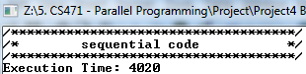
- In version 1, we are using single spinlock for 10 million data. Which means there will be a lot of delay because all process must wait if there is only one process that is locking the program. And since we only have one spinlock for all the data, the cost of the delay is tremendous and huge. Which we should not do in this case. And as we see, the result is the execution time took longer than expected.
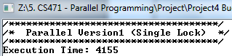
- In version 2, we are using multiple locks. Which can distribute the locking that was happening for 10 million data, therefore because we have a lot of locks, the process doesn't have to wait for a long time, resulting the process could run really fast, and even a lot faster rather than the single spinlock
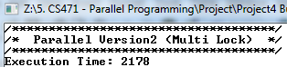
- In version 3, we don't give any locking at all which make no delay at all, resulting a very fast result, even thought we must change the algorithm to make sure that all the data will not produce the wrong result
